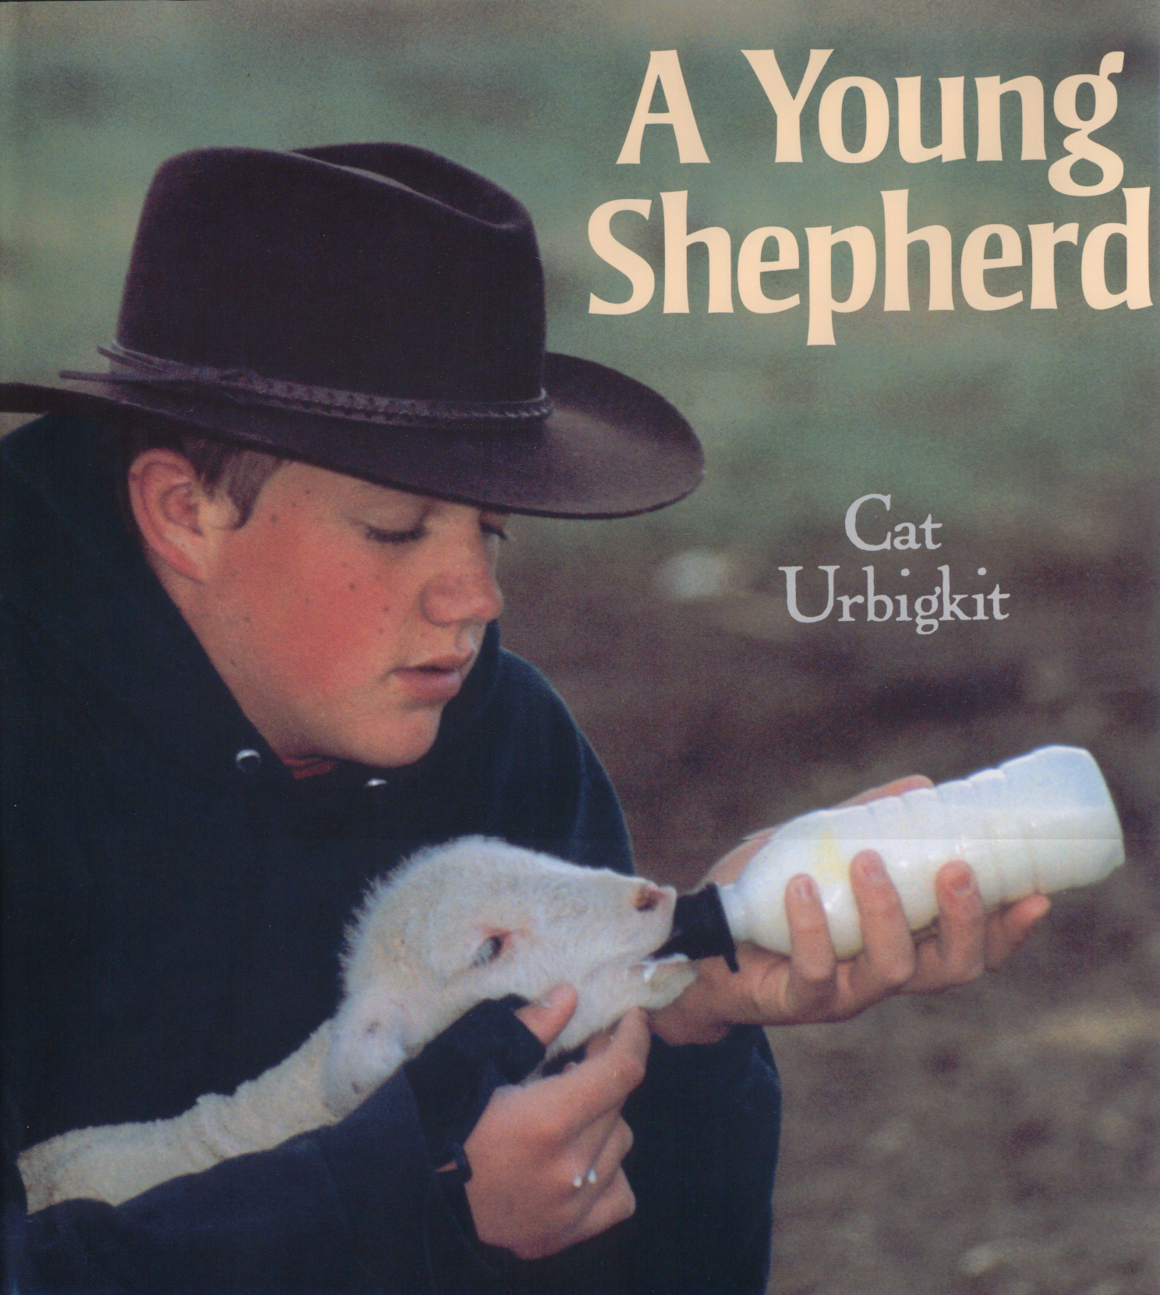
A Young Shepherd by Cat Urbigkit. Boyds Mills Press, 2006. Learn about raising sheep from Cass, a young shepherd who works on his family’s sheep farm in Wyoming. The book has simple, informative text and engaging photos and presents a fascinating glimpse of a hard but rewarding way of life. (grade 1 & up)

Order forms are found at www.wisagclassroom.org

Facts about sheep
Wisconsin (Source: WI Ag Statistics, 2005 Overview)
- There are about 85,000 head of sheep in Wisconsin.
- There were 67,000 sheep shorn with an average fleece weight of 7.3 pounds per animal. The total wool shorn was 490,000 pounds with a price of $.30/pound for a total value of $147,000.
- Cash receipts (from marketing and sale of farm slaughter) from sheep and lambs were $7,388,000 in 2005.

Nation-wide (Source: USDA Farms, Land in Farms, and Livestock Operations 2005 Summary. January 2006)
- The state with the most sheep: Texas with 1,090,000 sheep
- The top five states with sheep are: Texas, California, Wyoming, Colorado and South Dakota
- There are 68,280 sheep operations in the United States. Of those operations, 90.8% were comprised of 1-99 head, 7.6% had 100-499 head and 1.6% were operations of 500 head or more.
- There were about 6,135,000 head of sheep in the United States.
- Operations with 1-99 head account for 28.7% of the inventory, 100-499 head account for 24%, and 500+ head operations account for 47.3% of the sheep inventory.
- Cash receipts from sheep and lambs were $569,921,000 in 2005.

Other Fun Facts about Sheep (Source: American Sheep Industry Association Website)
- In 2004, the U.S. produced about 1.5 million pounds of sheep milk cheese and imported about 70 million pounds.
- The price of sheep milk was $.60 per pound in 2004- three times the price of cow’s milk.

Websites with information about sheep:
- www.sheep101.info – Interactive website with lots of information about sheep
- http://www.sheep.cornell.edu/sheep/index.html - Lots of information about sheep
- www.sheepusa.org – American Sheep Industry Association website
- www.wisbc.com – Wisconsin Sheep Breeders Co-op
- http://www.uwex.edu/ces/4h/onlinpro/sheep.cfm - Wisconsin 4-H - sheep projects
Answers: A Year in the Life Exercise: 7, 10, 9, 6, 2, 1, 8, 11, 3, 13, 4, 12, 5. Matching Exercise: F, B, G, C, D, A, E

Wisconsin Ag in the Classroom - www.wisagclassroom.org - 608-828-5719

